STONEY STANTON PARISH COUNCIL
CEMETERY & MEMORIAL POLICY
Stoney Stanton Parish Council (the burial authority) runs and maintains the small open cemetery located at Nock Verges, Stoney Stanton. There are no closing times.
The Cemetery site is split into an open and closed cemetery. The closed cemetery is maintained by Blaby District Council with regards to grass cutting and memorial safety.
The Cemetery is operated and managed under current legislation covering burial and cremation in England and Wales. Visitors are welcome to the Cemetery and are requested to respect the dignity of these peaceful places. The Council reserves the right to temporarily close to the public access to the Cemetery at any time without notice.
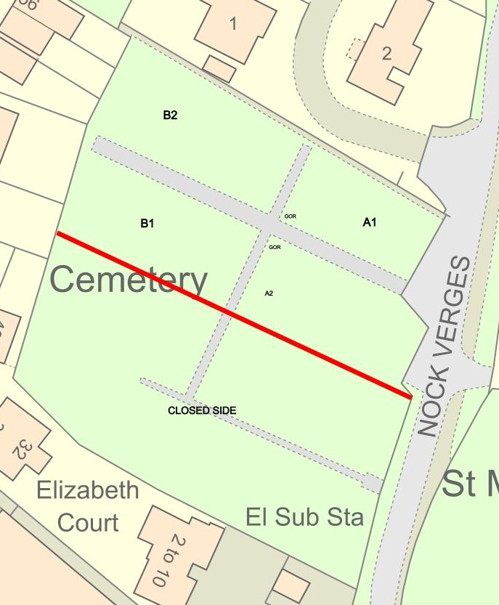
Although geographically located opposite St Michael’s Church and churchyard, the Parish Council has no association with the church or the records. There are no Commonwealth War graves in the cemetery.
Dogs including assistance dogs are allowed in the cemetery but must be kept on a lead and owners must clean up after the dogs. Children are permitted in the cemetery but should do so under the care and supervision of an adult.
The Parish Council and cemetery visitors all want to keep the site looking its best at all times so to help achieve this, we require graves to be kept in a neat, safe and tidy manner. Waste bins are provided at the entrance.
The Parish Council is responsible for the grounds maintenance such as the grass cutting, upkeep of the trees and the gardens of remembrance.
All persons shall conduct themselves in a decent, quiet and orderly manner and are reminded of the provisions of Articles 18(1) of The Local Authorities’ Cemeteries Order 1977. These state that no person shall:
* Wilfully create any disturbance in a cemetery
* Commit any nuisance in a cemetery
* Wilfully interfere with any burial taking place in a cemetery
* Wilfully interfere with any grave or memorial, or any flowers or plants or any such matter;
* Play at any game or sport in a cemetery.
Permission must be granted from the Parish Council for the use of musical instruments or sound producing equipment to be use within the cemetery.
No persons shall sell or offer for sale any item, article or thing of any kind whatsoever from within the cemetery.

What we offer
There are no exclusive rights of burial on this site which means that no one is able to purchase rights to a grave space and it is ran on a first come, first served basis. It is not possible to reserve or earmark plots for future use.
We offer single and double depth (triple can be considered if the ground is granted suitable by the gravedigger) for full burials and have a separate section for cremated remains and offer 2 gardens of remembrance with plaque walls for scattering of ashes.
Funeral services are organized through an undertakers and fees apply.
Income generated from interment is used to help maintain and improve the cemetery grounds.
New burials are allocated in the next available space but the Parish Council reserve the right to allocate spaces elsewhere within the cemetery should ground conditions or operational issues dictate.
All registers, records and plans of the cemetery are held in the parish office and requests for details should be send to clerk@stoneystanton.org.uk
Memorial headstones
Prior to installation of any memorial headstone, permission must be obtained from the Parish Council to ensure conformity to the dimensions required and that proposed inscriptions are appropriate. Your appointed memorial mason must contact the Parish Council on your behalf.
The memorial must be fixed to the foundation using an approved ground support system (as detailed in the National Association of Memorial Masons Code of Working Practice) and must be installed by a registered Memorial Mason.
Memorials on burial plots are usually installed after 6 months following a burial to allow for the ground to settle and this will be decided by the authorized memorial mason, burial headstones for a traditional grave must not exceed 36 ins. height x 36 ins. width x 4 ins depth.
Memorials for Cremated remains must not exceed 24 ins. height x 18 ins. width x 4 ins depth.
Memorial headstones must be in alignment with others in the row.
Installation of kerb sets are allowed if they do not exceed 7 feet x 3 feet.
Permanent vases are allowed in lieu of a headstone and must not exceed 12 ins height x 12 ins width.
Memorial tablets are accepted on burial plots if ashes have been interned and these must not exceed 18 inches x 18 inches.
Wall plaques and added inscriptions are allowed but permission must be granted and agreed. Plaques can be added on the memorial walls within the cemetery or the garden memorial wall at the village hall.
Any memorial that is not authorized and permitted by the parish council can be removed without any prior notice and any costs incurred will be charged to the family of the deceased.
The parish council reserves the right to refuse a permit of erection of a memorial if it is oversized, inappropriate, dangerous or offensive.
It is the memorial owners responsibility to ensure that they are kept in good repair. The owner is responsible for any repairs due to damage caused by vandalism, cracking, subsidence, weather etc.
The Parish Council will undertake memorial safety inspections every 5 years (as a legal requirement) and will contact owners should they need to and if no owners or family can be found the memorial will be laid down safely with the inscription facing up.
Rules on grave adornments
All tributes are placed at the owner’s own risk.
Flower containers must be secured within the grave space and not left to disturb other graves. Floral tributes will be removed by parish grounds staff once they have decayed. Artificial flower tributes/wreaths should be removed when faded or not later than 3 months after the event ie Christmas/Remembrance.
Any authorized, makeshift, unsafe and inappropriate installations will be removed and disposed of by the Parish Council.
Planting of trees and bushes is not permitted in the grave areas.
All plots must be considerate of the grave spaces and not cover, interfere or damage neighbouring graves.
All burial grave spaces are 8’ x 3’ (2440mm x 1524mm)
All cremated remains plots measure 3’ x 3’ (914mm x 914mm)

Memorial testing
All local authorities are required by law to carry out testing of memorials in cemeteries under their Duty of Care and safety in public places and following the guidelines produced by the Health and Safety Executive. This is not a task that the Parish Council undertakes lightly and every possible measure is being taken to minimize the impact of the testing particularly in relation to those memorials that are found to fail the testing.
Inevitably some Memorials failed the testing, it is necessary that a small discreet notice advising this until permanent repairs can be effected. It is hoped to avoid, where possible, the laying down of stones because of the distress it causes.
Responsibility then falls to the individual responsible for the Memorial to arrange for professional maintenance to bring it up to the current standards. The Parish Council will endeavour where possible to contact the relatives to notify them of the work required to the Memorial. In the event that no one has been found or has contacted the Council in regard to a Memorial found to be unsafe, then the Council has a duty of care to make it safe by either paying for the repairs or lay the memorial down face up.
Any questions, queries or concerns can be raised with the Parish Clerk by calling 07476 202575 or emailing clerk@stoneystanton.org.uk.
Exhumations
Any exhumations will only take place once you have obtained a Secretary of State’s Licence
You can apply for a Secretary of State’s Licence from: The Ministry of Justice, Coroners and Burials Division, 4.38 4th Floor 102 Petty France, London SW1H 9AJ. Telephone 0203 334 3555. Email: coroners@justice.gsi.gov.uk.

INFORMATION FOR FUNERAL DIRECTORS
Interment Bookings
All interment requests must be made on a Notice of Interment Form and be with the Parish Clerk 3 days prior to the internment and these details will be full and final. The parish council will not take responsiblity for any misunderstandings that may arise from a telephone instruction.
No interment shall take place without the prior knowledge and agreement of the Parish Clerk.
The fees and charges are available on the website and are reviewed annually.
Interments are not allowed on Sundays, Christmas Day, Good Friday and Bank Holidays.

Certificate of Disposal
Burials - The certificate of disposal issued by the Registrar of Births and Deaths must be with the parish clerk no later than the day prior to the funeral for completion and return immediately after the burial has taken place. In the case of a pre-24 weeks still born child a certificate from a medical practitioner will be produced.
Cremated remains – The cremation certificate must be with the parish clerk no later than the date of interment or scatter.
Religious Service
Any interment can take place with or without religious service, the funeral director or family of the deceased will decide who will officiate the service.
Coffin and Caskets
No interment will be permitted unless the body of the deceased person is fully enclosed in a traditional wooden coffin or ecologically friendly coffin or casket. Under no circumstances will the interment of metal or metal lined coffins be allowed in any grave.
The coffin size must be confirmed in writing. The size must be exact and include mouldings and any open handles. Any alteration to these sizes must be notified to the parish clerk and the gravedigger prior to the grave being dug.
Every coffin or casket must have attached some permanent form of identification marker or brass plate bearing the name of the deceased and their date of death.
Each individual body, whether an adult or child, must be brought to the cemetery in a separate coffin, except where: (a) a mother has died in childbirth, in which case both the mother and child may be interred in the same coffin; or (b) twins or multiple twins have died in childbirth, in which case the children may be interred in the same coffin, or (c) the parish clerk has exercised his/her discretion to authorise some other arrangement.
The parish clerk shall be informed by the person giving notice if the deceased suffered from or died of an infectious or notifiable disease or was exposed to radiation.
No Funeral Director or other person shall be permitted to remove coffin lids from any coffin at any interment within the cemetery on any pretence whatever. All treatment, washing or dressing of bodies must be undertaken prior to arrival at the cemetery.
Cremated remains must be contained in a casket or urn for burial within the cemetery fully identified with the name of deceased.
A Register of all burials shall be kept by the parish clerk.
Graves
Capacity of grave plots
a) For a grave intended for the burial of a single or double body depth it is then allowed a maximum of three further cremated remains caskets under turf;
b) Cremated remains interments may take place in a grave at casket depth as no further coffined burials can take place;
c) Each cremated remains plot contains sufficient space for two caskets.
Every grave shall be dug central to the allocated grave space.
All new graves shall be excavated at 1.83m (6’) subject to ground conditions allowing for two burials to take place in each grave space.
Re-opened graves will be excavated at 1.37 (4’6”), children’s graves shall be excavated at 1.20m (3’11”) and cremated remains plots at 0.30m (12”)
A person shall not in the burial ground cause a body to be buried in a grave in such a manner that any part of the coffin is at a depth less than 1.06m (3’6”) below the level of the surface of the ground adjoining the grave.

